
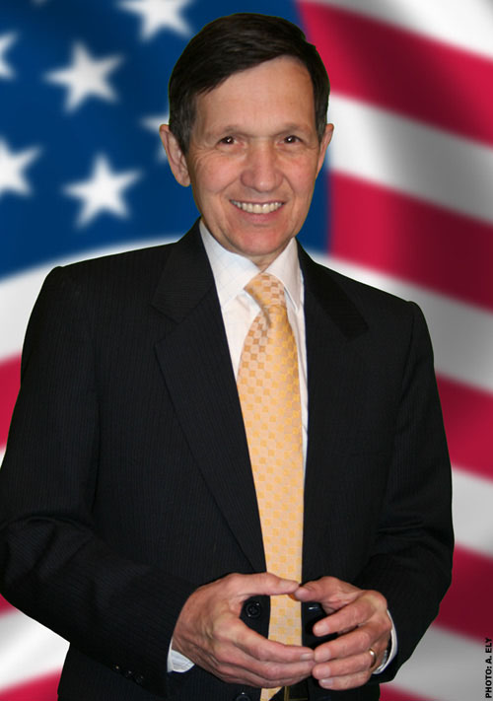

Volunteer Meetings
Thursdays 7-9pm
515 Broadway
Santa Cruz, Ca.
831-728-7090
woicle@yahoo.com

Dennis’ vision for America:
- Ending the war in Iraq and bringing the troops home within 3 months of taking office
- Universal not-for-profit Health Care
- Universal free pre-kindergarten and quality education through college
- Repeal NAFTA and WTO to help keep American jobs in America
- Balance between Workers and Corporations
- Repeal of the Patriot Act
- Environmental Renewal and Clean Energy
- Full Social Security Benefits at age 65

The Kucinich 12-Point Plan for Iraq
This is a condensed version that was introduced by Congressman Kucinich in the House of Representatives on January 9, 2007
1 The US announces it will end the occupation, close military bases, and withdraw.
2 US announces that it will use existing funds to bring the
troops and necessary equipment home.
3 Order a simultaneous return of all US contractors to the
United States and turn over all contracting work to the Iraqi Government.
4 Convene a regional conference for the purpose of
developing a security and stabilization force for Iraq.
5 Prepare an international security and peacekeeping force to move in, replacing US troops who then return home. The UN has an indispensable role to play here, but cannot do it as long as the US is committed to an occupation.
6 Develop and fund a process of national reconciliation
7 Reconstruction and Jobs. Restart the failed reconstruction program in Iraq. Rebuild roads, bridges, schools, hospitals, and other public facilities.
8 Reparations. The US and Great Britain have a high moral obligation to enable a peace process by beginning a program of significant reparations to the people of Iraq for the loss of lives, physical and emotional injuries, and damage to property.
9 Political Sovereignty. Put an end to suspicions that the US invasion and occupation was influenced by a desire to gain control of Iraq's oil assets.
10 Iraq Economy. Set forth a plan to stabilize Iraq's cost for food and energy, on par to what the prices were before the US invasion and occupation.
11 Economic Sovereignty. Work with the world community to restore Iraq's fiscal integrity.
12 International Truth and Reconciliation. Establish a policy of truth and reconciliation between the people of the United States and the people of Iraq.

Go to http://www2.kucinich.us/files/pdfs/12point_plan.pdf for full version of Denis Kucinich’s 12 point plan for Iraq

Join us Thursdays 7-9pm 831-728-7090
515 Broadway, Santa Cruz, Ca.

Universal Health Care IS Possible — NOW
Some candidates TALK about Health Care. Dennis Kucinich ACTS on Health Care.
Dennis Kucinich already has a bill before Congress (HR 676) to provide Universal, Single-Payer, NOT FOR PROFIT Health Care. HR 676 takes health care away from the insurance companies and gives it back to the PHYSICIANS. “Insurance companies are holding our health care system hostage and forcing millions of Americans into poverty with unconscionable premiums, co-pays, deductibles. We’ve got to have not-for-profit health care, get the insurance companies out of the picture. Health care is not a privilege, it is a right, and it is a human right.” — Dennis Kucinich at the SEIU Conference on health care — Las Vegas, Nev. — March 2007 Dennis Kucinich
HR 676 covers all health care needs, including dental care, mental health care, vision care, prescription drugs, and long-term care. You choose your health care providers, they provide the health care you need, the federal government pays the bills. 􀁺 No insurance companies, no HMOs, no deductibles, no pre-existing condition hassles, no co-pays. Complete portability. 􀁺 Veterans could go to any doctor they wanted. Farmers would not need an off-farm job just to keep their family covered. 􀁺 Unions would not have to bargain for health care benefits. Businesses would be able to better compete in the world market. 􀁺 Parents would not have to turn down jobs to stay below pre-set income limits just so their children have health care. 􀁺 Entrepreneurs could go into business for themselves without having to forego health care coverage for their families. 􀁺 There would be no danger of bankruptcy due to medical bills. Families would be more stable, life savings not at risk.

Dennis Kucinich on Civil Rights:
- Real GLBT equality includes the right to marry.
- Overturn the Patriot Act as unconstitutional.
- Civil marriage is not necessarily between a man & a woman
- Affirmative action is necessary & right & must be preserved.
Dennis Kucinich on Abortion:
- Women's right-to-choose is essential to gender equality.
- Abortions should always be legal.
- Supreme Court nominees must agree to uphold Roe v. Wade.
- Prevention, education, & health care, to minimize abortions.
Dennis Kucinich on Crime:
- End mandatory minimums.
- Ban the death penalty-98% of those convicted are poor.
- Focus on prevention, not punishment.
- Voted YES on funding for alternative sentencing instead of more prisons.
- Voted NO on more prosecution and sentencing for juvenile crime.
Dennis Kucinich on the War on Drugs:
- Medical marijuana should be decided by doctors & patients.
- Hasn't smoked marijuana, but would decriminalize it.
- Emphasizes rehabilitation over incarceration.
- War on Drugs benefits only the prison-industrial complex.

Dennis Kucinich on Education:
- End No Child Left Behind; end testing as be-all & end-all.
- Free education from pre-kindergarten to college.
- Fund universal pre-K with 15% cut in Pentagon budget.
- Teach sex ed in schools; including AIDS prevention.
- Vouchers divert public money away from public schools.
- Reduce class size to 18 children in grades 1 to 3.
- Opposes requiring schools to allow school prayer.
Dennis Kucinich on the Environment:
- Supports the Kyoto Protocol on global climate change.
- Strengthen environmental laws and increase penalties on polluters.
- Investment in alternative energy sources, including hydrogen, solar, wind, and ocean.
Dennis Kucinich on Corporations:
- Break up monopolies in agriculture, in utilities, in oil.
- Democracy fails without corporate regulation.
- Iraq: no more Halliburton sweetheart deals.
- Need separation of corporation and state.
Dennis Kucinich on Immigration:
- Build relationships between nations, not walls.
- Immigrants are not to blame for our labor problems.
- Roadmap to citizenship for immigrants.

About Dennis Kucinich:
Dennis Kucinich was born in Cleveland, Ohio on October 8, 1946. He is the eldest of seven children of Frank and Virginia Kucinich. He and his family lived in twenty-one places, including a couple of cars, by the time Kucinich was 17 years old. "I live each day with a grateful heart and a desire to be of service to humanity," he says.

Kucinich first came to national prominence in 1977 when he was elected mayor of Cleveland at age 31, the youngest person ever elected to lead a major American city. Kucinich has promoted a national health care system, preservation of Social Security, increased Unemployment Insurance benefits, and the establishment of wholesale cost-based rates for electricity, natural gas and home heating oil. In his Cleveland, Ohio district, Kucinich has been recognized by the Greater Cleveland AFL-CIO as a tireless advocate for the social and economic interests of his community.

Congressman Kucinich acts upon his belief that protection of the global environment is fundamental to preserving the life of all species. He has been honored by Public Citizen, the Sierra Club, Friends of the Earth and the League of Conservation Voters as a champion of clean air, clean water and an unspoiled earth. He has been recognized for his advocacy of human rights in Burma, Nigeria and East Timor, and received the Ghandi Peace Award in 2003.

For more information on Dennis Kucinich call Kucinich for President 2008 Toll free:

1-877-41-DENNIS
or visit:
www.dennis4president.com

Join Us Thursdays 7-9pm
515 Broadway, Santa Cruz, Ca.
831-728-7090 woicle@yahoo.com

